Linux Processes Commands Exercises

**Beginner Level**
1. List all running processes
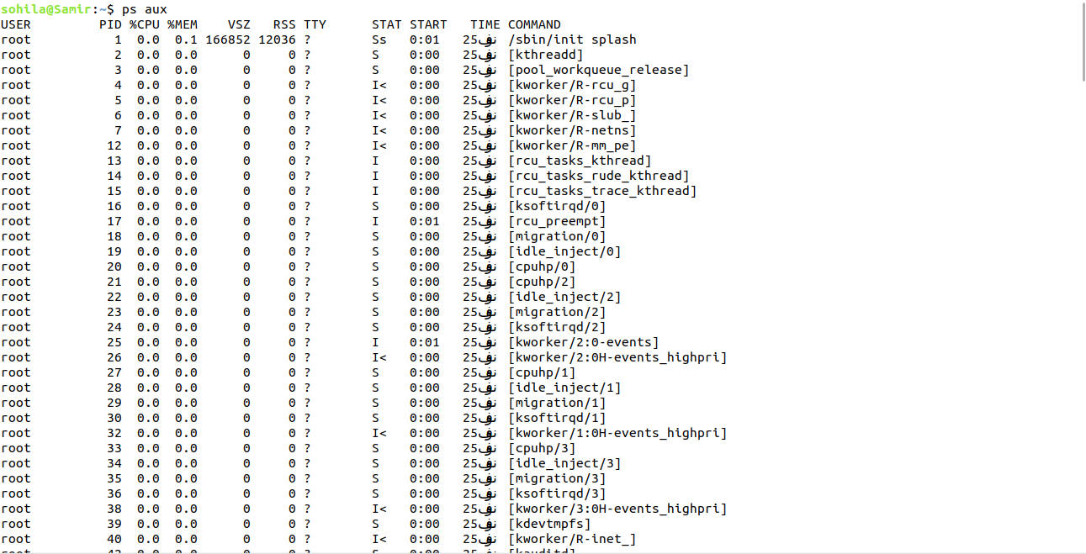
Use the `ps` command to list all processes running on your system.

2. Monitor system processes in real-time
Run the `top` or `htop` command and identify the most CPU-intensive process.
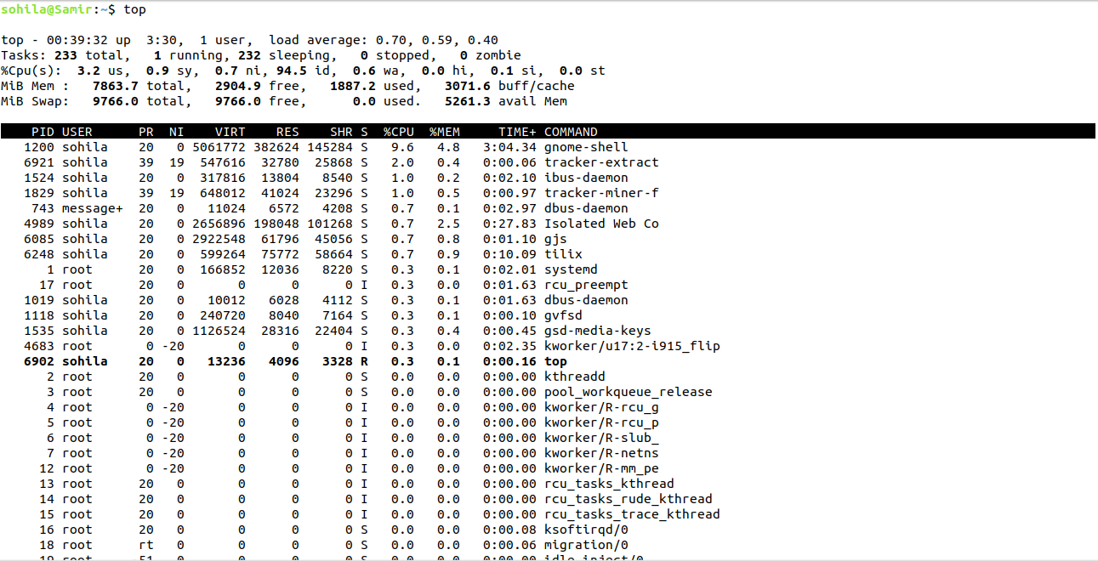

3. Start a background process
Launch a command like `sleep 30` in the background using `&`.
- Verify it is running using `jobs` or `ps`.

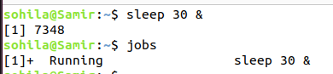
4. Bring a background process to the foreground
Use `fg` to bring the background process back to the foreground.
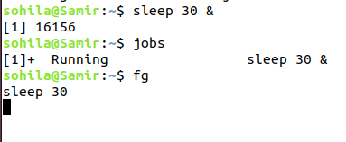

5. Suspend and resume a process
- Start a long-running process (e.g., `ping google.com`).
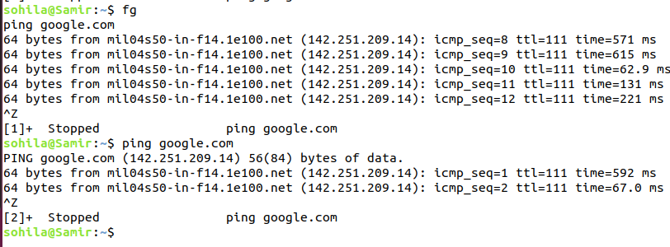
- Suspend it using `Ctrl+Z` and resume it with `fg` or `bg`.

**Intermediate Level**

6. Kill a process by PID
- Start a process (e.g., `sleep 300`).- Find its Process ID (PID) using `ps` or `pgrep`.
- Kill it using the `kill` command.
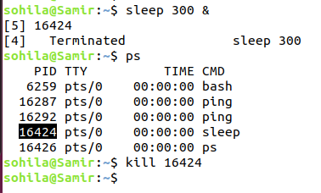

7. Terminate multiple processes
- Start multiple processes (e.g., `sleep 100`, `sleep 200`).
- Use `pkill` to terminate all processes with a specific name.
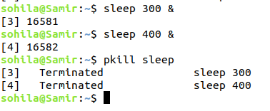

8. Niceness levels
- Start a command with a low priority using `nice` (e.g., `nice -n 10 sleep 100`).
- Check its priority using `ps -o pid,ni,comm`.
- Change its niceness using `renice`.
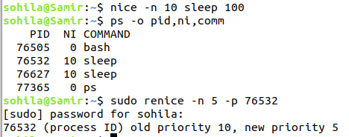

9. View process hierarchy
Use the `pstree` command to view the parent-child relationships of processes.
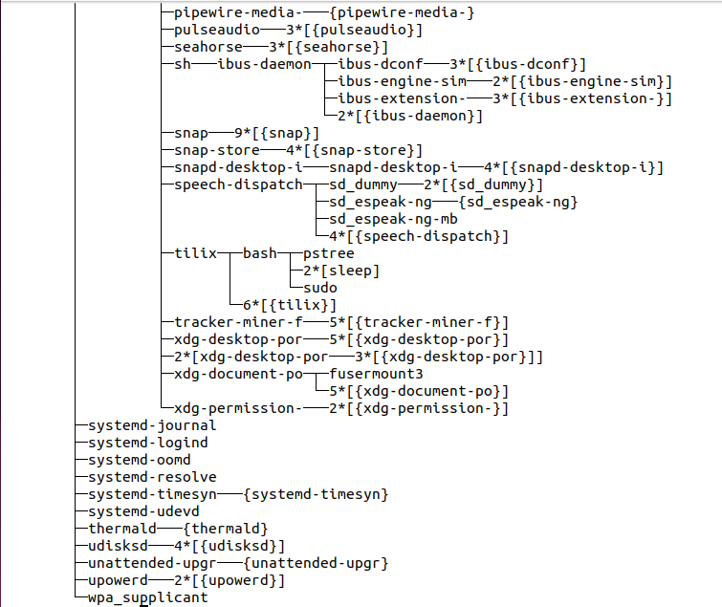

10. Redirect process output
Run `ping google.com` and redirect its output to a file using `>` or `>>`.
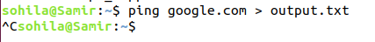

**Advanced Level**

11. Track system calls of a process
Use `strace` to trace system calls of a command like `ls`.
Example: `strace ls`.

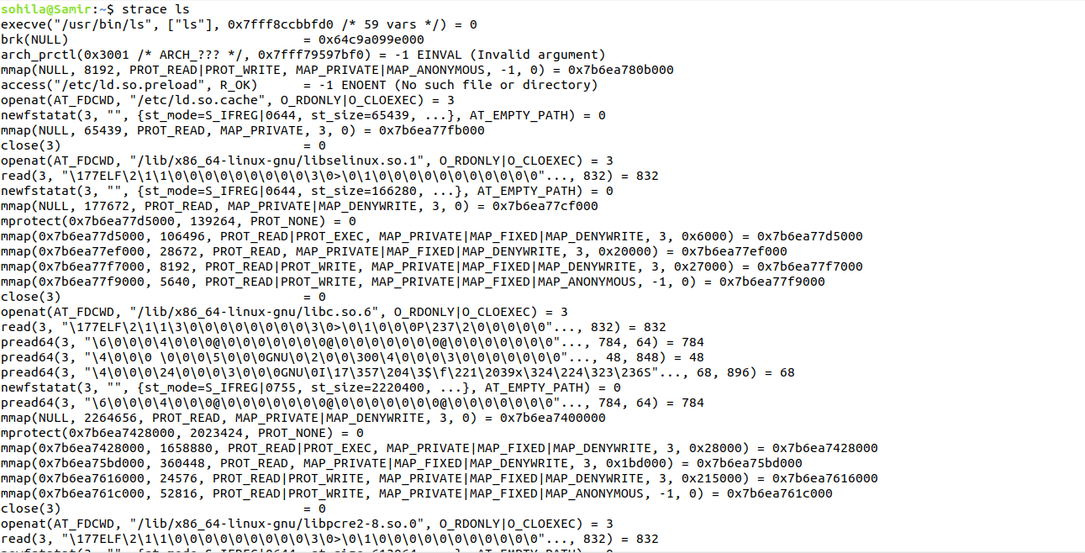

12. Monitor file descriptors
- Start a process like `cat`.
- Use `lsof -p <PID>` to check the file descriptors in use by the process.

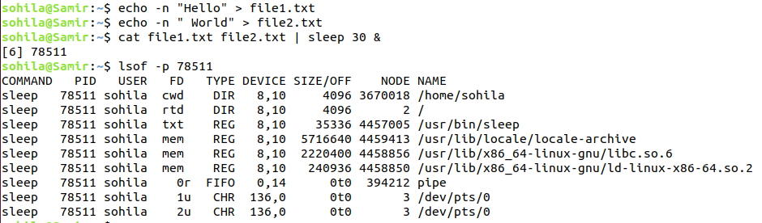

13. Process scheduling policies
- Start a process with `chrt` to set a real-time scheduling policy.
Example: `chrt -f 10 sleep 100`.
- Check its policy using `ps`.
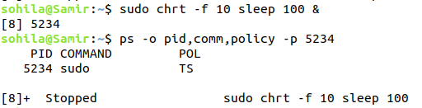

14. Create and terminate a zombie process
- Write a simple C program that forks but doesn't call `wait`.
- Observe the zombie process using `ps` and terminate its parent.
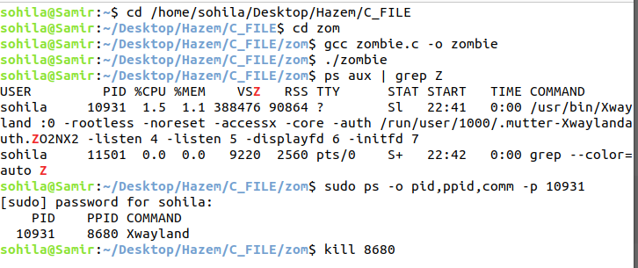

15. Limit resource usage
- Use `ulimit` to limit the CPU time or memory for a process.
Example: `ulimit -t 5` followed by a CPU-intensive command like `dd if=/dev/zero of=/dev/null`.
